Jordan Roberts

August 6, 2020

BAN 530

Prescriptive Model Building

Throughout our analysis, I have seen several geographic and statistical trends in the COVID-19 data. Europe and the Americas have the highest deaths in relation to population. The Middle East has had the largest increase day to day since the beginning of the pandemic. Africa has had the lowest incidence of COVID-19 issues.

My model building has focused mainly on countries and US counties above or below the average, as well as their associated generalized regions. We can revisit this data to determine potential solutions.

**Country Reanalysis**

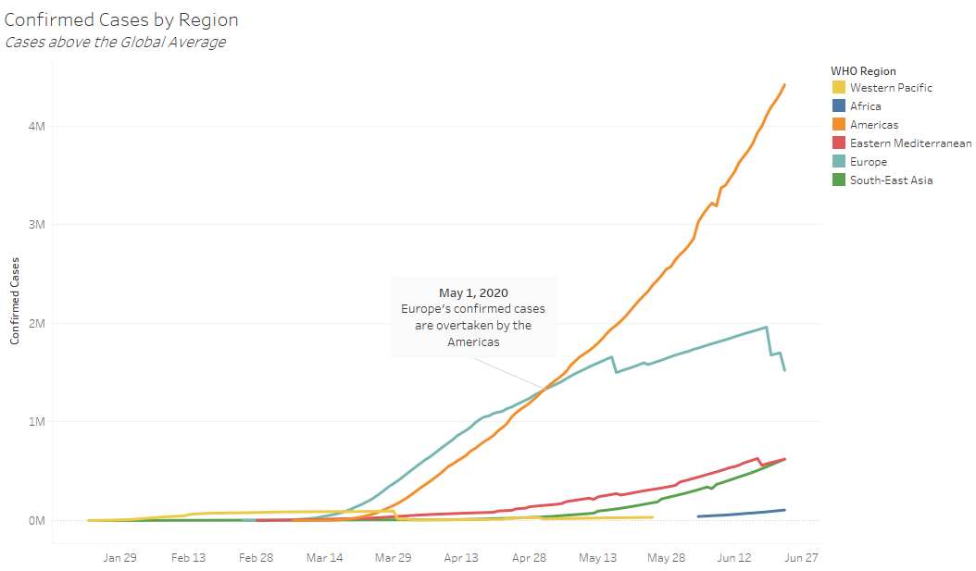

China was ground zero for COVID-19, but its region (Western Pacific) eventually dropped below the global average. Africa only reached the global average around the start of June. South-East Asia and the Mediterranean began climbing, but the infection rate was not quite as steep as other regions.

Europe rose above the global average sometime in February, with cases rising exponentially into March and April. However, the curve flattened out somewhat, though numbers are still high. The Americas took off once infections started and never flattened out.

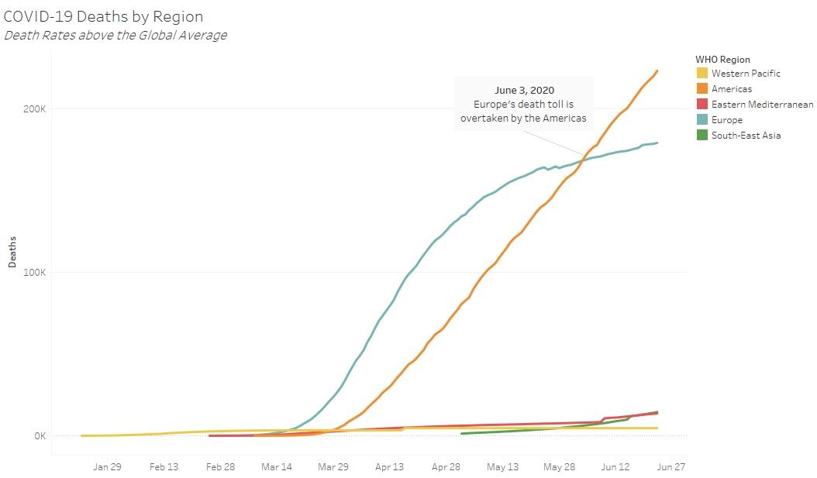

COVID-19 has an extended incubation period, meaning that if deaths happen, they will typically happen sometime after infection has been confirmed. This explains the lag between the first and second graphs.

Here we can see that even though China and its neighbors got infection rates under the global average, the death toll has been steady through the end of our data. South-East Asia had cases almost immediately, but deaths were not out of control until the beginning of May. Africa’s death toll never reached above the global average, although they only started having record case numbers towards June.

Europe saw a huge spike in deaths toward the end of March. Case numbers were overtaken by the Americas almost a full month before deaths were. Europe’s struggle with keeping patients alive is apparent. However, the Americas were consistent in their exponential increases in both case numbers and death tolls.

What steps can be taken to keep our infection rates and deaths under control? Africa is starting to climb in June, and South-East Asia and the Mediterranean are both on the rise as well. How can we keep these regions from building the momentum Europe and the Americas gathered?

**Prescriptive Analysis**

The main takeaway here is that widespread infections compound themselves and spread even further. China started off with massive infections, but while they did spread throughout the world, nearby countries did not let it run out of control. This region of the world managed to get things under control, according to their own data, while the Americas and Europe reached runaway levels of infections. The SARS epidemics from the beginning of the millennium were centrally located in Asia, so these countries have precedent for the common cautionary methods promoted today by the WHO and other major health organizations.

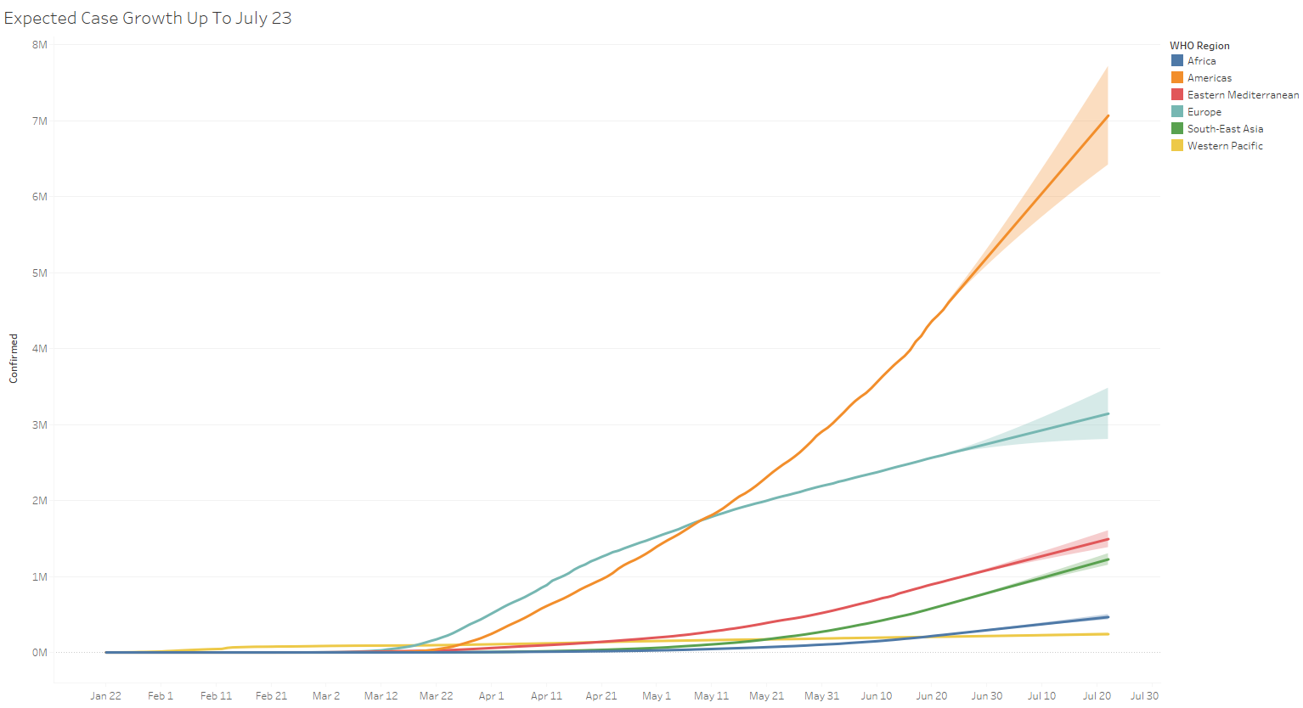

At current rates, The Americas will break seven million cases a month after our data ends. All regions of the world will continue growing, though none at the Americas’ pace.

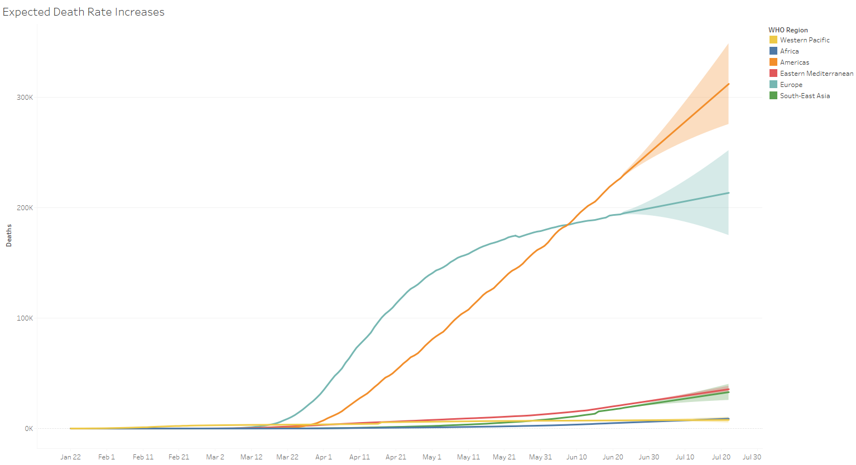

It is obvious that the Americas and Europe are the hardest hit in this pandemic, and thus require the most resources. We should not ignore the Mediterranean and South-East Asian countries, though, as they are still showing steady growth in both statistics. I will focus on remedies for the US in my county analysis, but we can at least look at Europe and the rest of the Western Hemisphere.

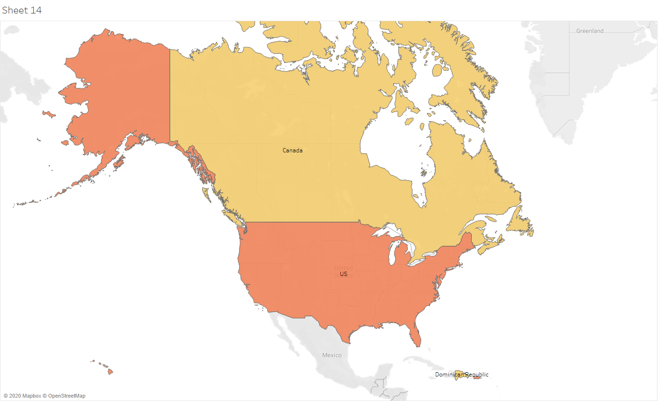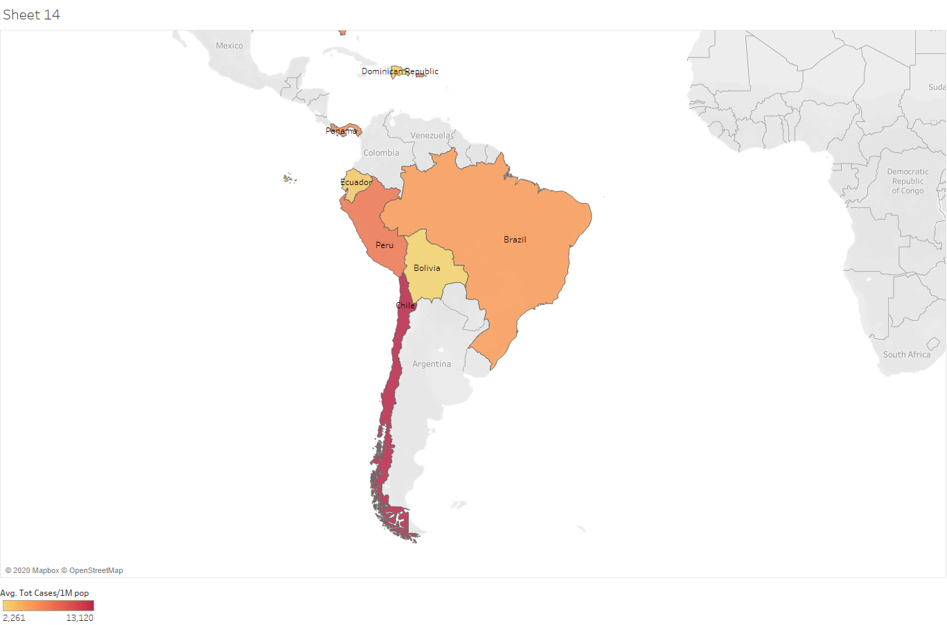

These are the American countries with higher-than-average case numbers, adjusted for population. Latin America was one of the last areas of the world to receive COVID-19 infections. Chile is the worst off with 13,120 confirmed cases for every one million citizens. Peru has 7,913 cases per one million citizens. At least 140 million people in Latin America and the Caribbean work in the informal sector, according to a recent report by the International Labor Organization (ILO) [Toledo, 2020]. Many people cannot afford to shelter at home or stock supplies, so they are forced to venture out and be near others to survive. Economic factors play a huge role in the average Latin American citizen’s pandemic strategy.

Ventilators are also in short supply worldwide, and these countries are no exception. For example, Peru, with over 100,000 cases as of June 22, had only 40 ventilators and 1,002 ICU beds nationwide in May [Duque, 2020]. Brazilian health officials urged that borders with neighboring countries like Venezuela be closed due to outside nations’ failing health systems potentially leading citizens across the border for treatment [Boadle, Stargardter, Paraguassu, 2020]. Wealth inequalities and a general unpreparedness for the pandemic lead to an overloading of health systems and scrambling to provide treatment.

According to our predictive model, countries in North and South America start reaching above the global average around 9,000 cases with no recoveries. Without proper medical equipment or training, recoveries are hard to ensure. Before this level is reached, if ventilators and ICU beds are in short supply and decent recovery rates are unlikely, mandatory stay-at-home orders should be implemented alongside stimulus packages to ease the burden on households. As recoveries increase, the situation comes under better control and the country’s infection level should ease enough to allow functions to continue.

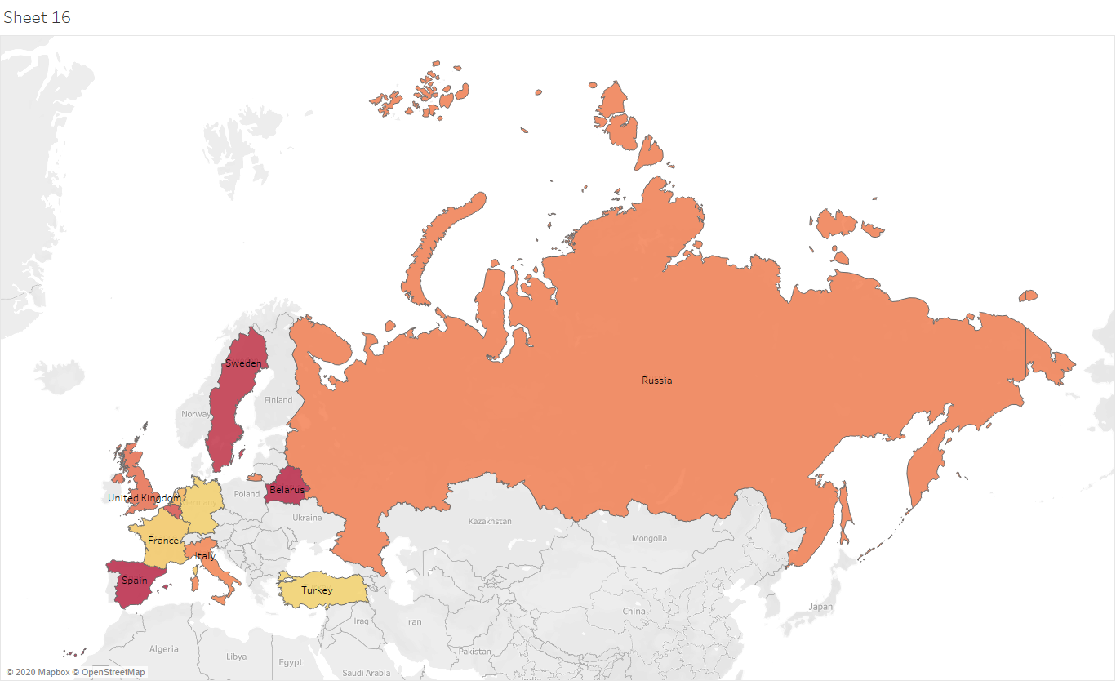

Belarus, Sweden, and Spain have the highest concentrations of cases in Europe, each over 0.6% infection rate for the population. Belarusian President Alexander Lukashenko has repeatedly downplayed the pandemic’s seriousness, encouraging citizens to continue as normal and proudly claiming that no one was dying from the virus but from other diseases and health issues [Makhovsky, 2020]. Spain had a particularly slow response to the initial outbreaks, partly due to the large number of autonomous communities located across the country, whose separate healthcare systems had to be unified to properly fight the virus [Jiménez, 2020]. The virus’s spread was facilitated by the open borders of the European Union, which remained open for some time after the virus began transmitting throughout the world. Travelers from many different nations were able to congregate in and pass through much of Europe, spreading the virus quite readily. Refusal to acknowledge the virus’s serious nature, coupled with a crippled healthcare system still reeling from the 2008 economic collapse, led to unpreparedness in the face of the pandemic.

According to our predictive model, Europe required much fewer cases to reliably reach above the global average. With many of the same issues arising as in the Americas, the same solution must be applied in the future. Countries approaching the critical level (around 7,000 cases with no recoveries) should be shut down completely, with borders closed. Stimulus payments to handle economic unrest should be enacted as well.

**County Reanalysis**

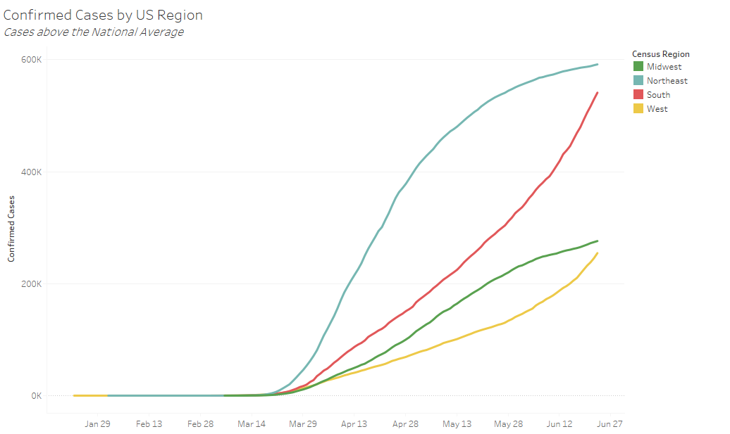

Although COVID-19 entered the US in the West, this ended up being the least affected region by April (excluding US Territories). The Northeast saw an explosion in cases before the curve began to flatten. The South and Midwest took a little longer to build cases, but case growth has accelerated in the South, leading to an eventual overtaking of the Northeast’s momentum.

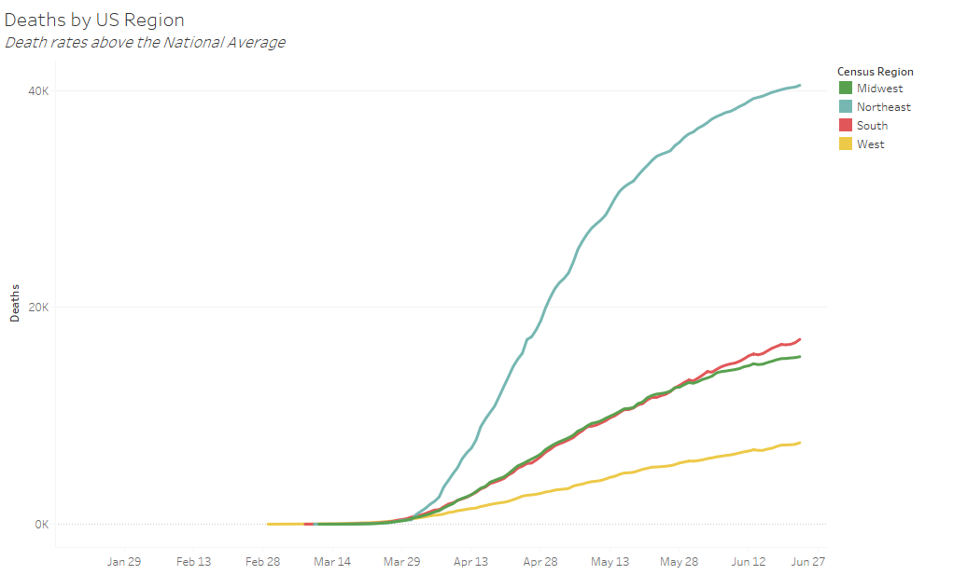

Similar trends can be seen here, where the Northeast’s death rate has far exceeded other regions at a much quicker pace. Unlike with confirmed cases, the other three regions have not had quite the upsurge in deaths. However, this could change in the future as deaths tend to lag behind cases naturally.

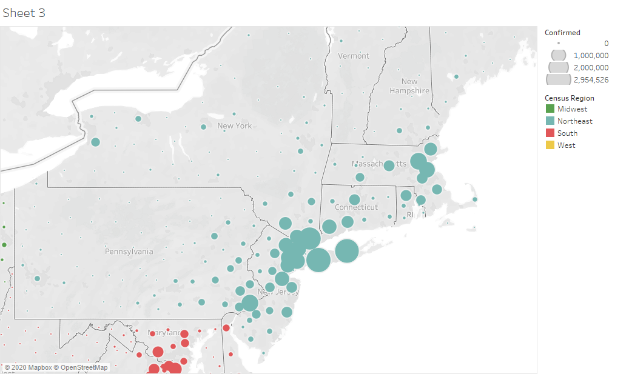

New York was known as the epicenter of the COVID-19 epidemic as of the end of our data, but its numbers were so high that all other county data was heavily skewed and underrepresented. I excluded New York City from the dataset as an outlier, but it is important to understand how massive the effects were from this one county. We can clearly see the spillage from the southern tip of New York state. New York City is the most populous city in the US, more than double the population of the second largest, Los Angeles. In addition, it is a famous tourist destination for people across the world. The tight quarters and attractive location were a perfect storm for foreigners and locals alike to spread the virus. As one of the origin points of the US pandemic, local governments denied the seriousness of the virus, much like in Europe and South America. The delay before implementing safety measures allowed the virus to spread into neighboring counties, as seen in the density map.

The same happened in Los Angeles, Chicago, Houston, and most major cities. The delay and refusal to shut down economic operations, especially from the federal government, increased transmission rates.

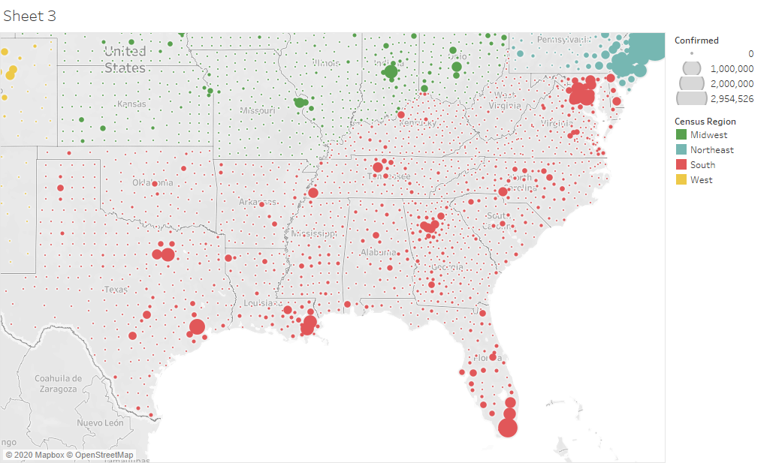

The South has seen great growth through the end of June, and many states began to open toward the beginning of summer. Another popular tourist destination, Miami, is seen at the tip of Florida. Cases spiked in early summer as vacationers and partygoers flocked south. The United States is almost twice the size of the European Union with more citizens. Shutting down a country’s borders is easier than shutting down each state or county line, especially with state governments having autonomy much like Spain’s autonomous communities. Because of this, many people continued life as normal, traveling across the country and taking the virus with them.

The federal government consistently urged states to open back up to normal economic functions, even threatening to hold back funding if certain aspects (such as education) did not return to normal. This was a poor decision in many counties, especially in the South. The virus continued its spread as hospitals struggled to keep patients under proper care. However, for the most part US counties have avoided cases altogether, according to the data available. Some of the more remote counties seem prime for avoiding the virus. In any case, the federal government has sent out stimulus checks, but until cases across the country can be contained it seems more help is needed.